
Epidemiological profile of people affected by tuberculosis in Cajazeiras, Paraíba, Brazil, between 2009 and 2019
Perfil epidemiológico de acometidos por tuberculose em Cajazeiras, Paraíba, Brasil, entre os anos de 2009 e 2019
¹Mestre em Farmácia, Universidade de São Paulo (USP). Orcid: 0000-0001-7359-3095.
² Doutora em Desenvolvimento e inovação tecnológica em medicamentos, Universidade Federal da Paraíba (UFPB). Orcid: 0000-0002-5252-2850.
³Profª. Drª. Universidade Federal de Campina Grande (UFCG). Orcid: 0000-0002-0321-7163.
⁴Prof. Dr. UFCG. Orcid: 0000-0003-1396-4645.
⁵Profª. Drª. UFCG. Orcid: 0000-0002-1418-431X.
⁶Doutorando em Neurociência Cognitiva e Comportamento, UFPB. Orcid: 0000-0002-6144-8445.
⁷Doutora em Farmacologia, UFPB. Orcid: 0000-0002-8884-7331.
⁸Doutor em Farmacologia, Graduando em Medicina, Universidade Estadual do Piauí (UESPI). Orcid: 0000-0003-0681-8439.
E-mail: juniorfarmacia.ufcg@outlook.com

Gustavo Fernandes Queiroga Moraes¹, Anna Paula de Castro Teixeira², Vanessa Santos de Arruda Barbosa³, Egberto Santos Carmo⁴, Igara Oliveira Lima⁵, Rafael Gomes Firmino⁶, Laísa Vilar Cordeiro⁷, Francisco Patricio de Andrade Júnior⁸
(

RESUMO

Esta pesquisa teve como objetivo investigar o perfil epidemiológico de acometidos por tuberculose em Cajazeiras-PB, entre os anos de 2009 a 2019. Trata-se de um estudo epidemiológico, analítico e documental. Os dados secundários foram coletados por meio do Departamento de Informática do Sistema Único de Saúde (DATASUS). Entre os anos de 2009 e 2019, foram notificados 275 casos de tuberculose. O perfil epidemiológico de acometidos foram predominantemente de indivíduos do sexo masculino (69,4%), com 20 a 39 anos de idade (44,4%), residentes na zona urbana (86,2%), com confirmação laboratorial (69,5%) e forma clínica majoritariamente pulmonar (86,9%). Ao correlacionar o sexo aos fatores imunossupressores, o sexo masculino demostrou maior número de casos para o Vírus da Imunodeficiência Humana, Síndrome da Imunodeficiência Adquirida, alcoolismo, tabagismo e diabetes Mellitus, contudo não observou a associação estatística entre as variáveis (p>0,05). Assim, é necessário à criação de políticas públicas para as populações de risco.

Palavras-chave: Tuberculose. Mycobacterium tuberculosis. Epidemiologia.

ABSTRACT

This research aimed to investigate the epidemiological profile of people affected by tuberculosis in Cajazeiras (PB), Brazil, between the years 2009 to 2019. This was an epidemiological, analytical and documentary study. The secondary data were collected through the Brazilian public health system Informatics Department (DATASUS). Between 2009 and 2019, 275 cases of tuberculosis were reported. The epidemiological profile of those affected was predominantly male (69.4%), aged 20 to 39 years (44.4%), living in the urban area (86.2%), with laboratory confirmation (69.5%) and the clinical form is mainly pulmonary (86.9%). When correlating sex with immunosuppressive factors, males showed a higher number of cases for human immunodeficiency virus, acquired immune deficiency syndrome, alcoholism, smoking and diabetes Mellitus, however there was no statistical association between the variables (p>0,05). Thus, it is necessary to create public policies for populations at risk.

Keywords: Tuberculosis. Mycobacterium tuberculosis. Epidemiology.

1. INTRODUCTION

The bacillus Mycobacterium tuberculosis is the etiological agent responsible for causing tuberculosis. This bacterium is an intracellular pathogen that initially affects the lungs. However, in certain situations, it can spread by hematogenous route, with the appearance of extrapulmonary tuberculosis with involvement of several organs, such as meninges, lymph nodes, pleura, abdomen, genito-urinary tract, skin, joints and bones. However, this clinical condition occurs mainly in individuals with severe immunocompromise.¹
The transmission of the disease occurs through inhalation of the bacteria present in aerosolized saliva droplets and expelled through the coughing and/or sneezing of infected individuals.²
Once the mycobacterium reaches a healthy individual, it needs to pass through the upper airways until reaching certain locations of the lower airways, more specifically the alveoli. When this tissue is affected, there are stimuli related to various tissue and immunological responses characteristic of the infection, thus triggering an inflammatory process in the affected region. In this context, different immune cells (macrophages and dendritic cells) accumulate in this location, involving them, to destroy them, forming the tuberculous granuloma. In this way, the bacillus lasts in a latent state inside the cells, until the individual shows immunosuppression.³
The initial clinical picture of tuberculosis is variable, as it depends on the organism of each patient, and can vary from asymptomatic form, during a limited period, to the symptomatic stages and the most advanced form of the condition. Among the symptoms that may appear in the course of the disease, it is possible to highlight dry or productive cough, weight loss, fever, sweating and fatigue.⁴
Regarding the diagnosis of the disease, there is the laboratory examination (direct bacilloscopy by the Ziehl-Nielsen method), imaging (high resolution radiography and computed tomography), clinical-epidemiological and histopathological tests, in addition to molecular tests, immunological (detection of interferon gamma) and adenosine deaminase.⁵
In this sense, the recommended treatment, according to the current recommendations, comes from the administration of several drugs, being these rifampicin, isoniazid, pyrazinamide and ethambutol, for a period of six months, aiming the cure and the rapid reduction of the transmission of this condition. In addition, there is the Bacilo de Calmette and Guérin (BCG) vaccine as the main mode of prophylaxis.⁶
Due to its high infectivity, pathogenicity, mortality and cost related to therapy, tuberculosis continues to be considered a global concern, being therefore classified as a public health problem common to all countries by the World Health Organization (WHO). Among the 22 countries with the highest reported cases, Brazil ranks 15th. Most of those infected are in the age group of 20 to 49 years.⁷
In view of this, considering the absence of epidemiological studies focused on the theme in the available scientific collection, the present study aimed to investigate the epidemiological profile of people affected by tuberculosis in Cajazeiras, (PB), Brazil, between the years 2009 and 2019.

2. MATERIAIS E MÉTODOS

- Study design
This is an epidemiological, analytical and documentary study, whose information was extracted through the Brazilian public health system Informatics Department (Departamento de Informática do Sistema Único de Saúde, DATASUS).

- Study location
The city Cajazeiras is in the Northeast region of Brazil, more specifically, in the countryside of the Paraíba state. The estimated population for 2019 was 61,993 inhabitants, with an income of 1.7 Brazilian minimum salaries for formal workers in 2017. In 2009, in relation to health, there were 33 establishments linked to the Brazilian public health system (Sistema Único de Saúde, SUS), with 54.8% of adequate sanitation in 2010.⁸

- Analyzed variables
The variables year, sex, age group, area of occurrence, clinical forms, laboratory confirmation and immunosuppressive factors were analyzed.

- Statistical analysis
The Statistical Package for Social Sciences software, version 13.0, was used for statistical analysis, in which absolute and relative frequencies were calculated for all variables.
There was an association between the variables sex and age, as well as sex and immunosuppressive factors. In addition, the Chi-Square Independence test was used, in which P < 0.05 was considered statistically significant for the null hypothesis.

3. RESULTADOS

From 2009 to 2019, in the municipality of Cajazeiras (PB), 275 cases of tuberculosis were reported, as can be seen in the Figure 1.

Figure 1. Percentage of confirmed TB cases in Cajazeiras-PB between the years 2009 to 2019.
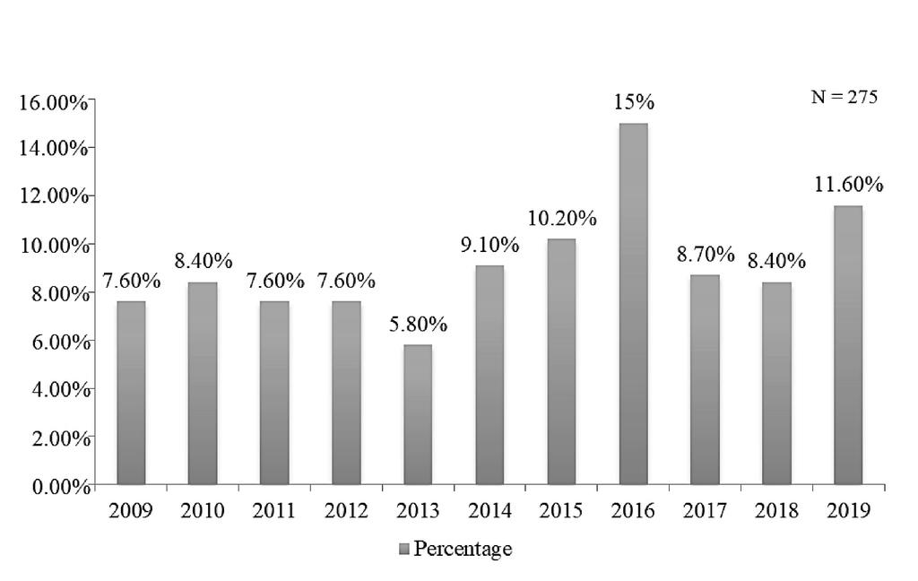

Source: Research data, 2020.

The association between the age group and gender affected by tuberculosis can be seen in Table 1.

Table 1. Association between age group and gender of people affected by TB in Cajazeiras-PB between the years 2009 to 2019.
Age range | Male gender |  | Feminine gender |  | Total by gender and age group
 | N | % | N | % | N | %
< 1 ano | 02 | 1.1 | 00 | 0.0 | 02 | 0.7
1-4 | 01 | 0.5 | 00 | 0.0 | 01 | 0.4
5-9 | 02 | 1.1 | 00 | 0.0 | 02 | 0.7
10-14 | 01 | 0.5 | 00 | 0.0 | 01 | 0.4
15-19 | 06 | 3.1 | 05 | 6.0 | 11 | 4.0
20-39 | 81 | 42.4 | 41 | 48.8 | 122 | 44.4
40-59 | 67 | 35.1 | 26 | 30.9 | 93 | 33.8
60-69 | 19 | 9.9 | 06 | 7.1 | 25 | 9.1
70-79 | 07 | 3.7 | 05 | 6.0 | 12 | 4.3
≥ 80 | 05 | 2.6 | 01 | 1.2 | 6 | 2.2
Total | 191 | 100 | 84 | 100 | 275 | 100
Source: Research data, 2020.

Table 2 shows the area of residence of those affected by tuberculosis.

Table 2. Area of occurrence and cases of people affected by TB in Cajazeiras-PB between the years 2009 to 2019.
Residence zone | N | %
Urban | 237 | 86.2
Rural | 30 | 10.9
Ignored | 08 | 2.9
Total | 275 | 100
Source: Research data, 2020.

In figure 2 it is possible to observe the percentage of the clinical forms of TB.

Figure 2. Percentage of the clinical forms of TB of people affected by tuberculosis in Cajazeiras-PB between the years 2009 to 2019.

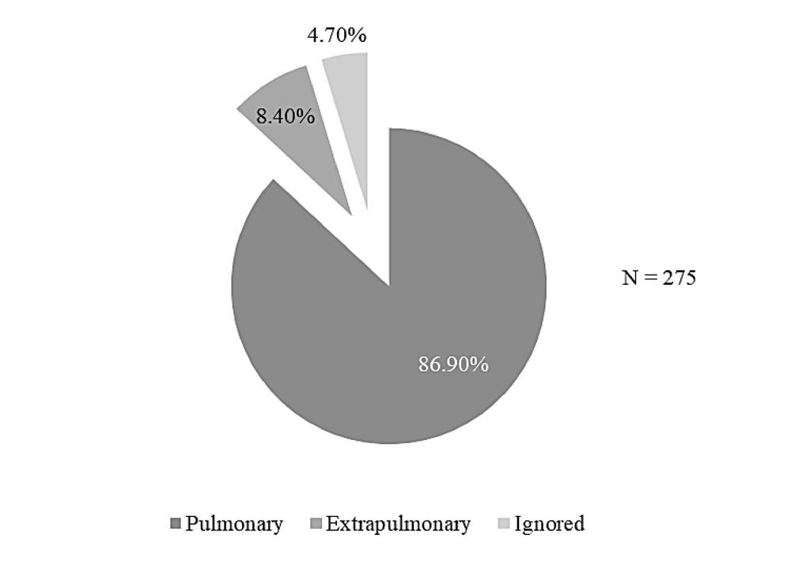

Source: Research data, 2020.

Table 3 shows the association between the sex of people affected by tuberculosis and immunosuppressive factors.

Table 3. Association between gender and immunosuppressive factors of people affected by TB in Cajazeiras-PB between the years 2009 to 2019.
Immunosuppressive factors | Male gender |  | Feminine gender |  | Total |  |  |  |  | p
 | N | % | N | % | N |  | %
HIV
Positive | 11 | 5.8 | 08 | 9.5 | 19 |  | 6.9
Negative | 106 | 55.5 | 48 | 57.1 | 154 |  | 56.0 |  |  | *
In progress | 14 | 7.3 | 09 | 11.0 | 23 | 8.3
Unrealized | 50 | 26.2 | 17 | 20.0 | 67 | 24.4
Ignored | 10 | 5.2 | 02 | 2.4 | 12 | 4.4
Total | 191 | 100 | 84 | 100 | 275 | 100
AIDS
Yes | 10 | 5.2 | 06 | 7.0 | 16 |  | 5.8
No | 120 | 62.8 | 59 | 70.0 | 179 |  | 65.1 |  |  | 0,273
Ignored | 61 | 32.0 | 19 | 23.0 | 80 |  | 29.1
Total | 191 | 100 | 84 | 100 | 275 |  | 100
Alcoholism
Yes | 49 | 25.6 | 01 | 1.2 | 50 |  |  | 18.2
No | 97 | 50.8 | 59 | 70.2 | 156 |  |  | 56.7 |  | *
Ignored | 45 | 23.6 | 24 | 28.6 | 69 |  |  | 25.1
Total | 191 | 100 | 84 | 100 | 275 |  |  | 100
Smoking
Yes | 17 | 9.0 | 06 | 7.0 | 23 |  |  |  | 8.4
No | 69 | 36.1 | 29 | 35.0 | 98 |  |  | 35.6 |  | 0,829
Ignored | 105 | 54.9 | 49 | 58.0 | 154 |  |  | 56.0
Total | 191 | 100 | 84 | 100 | 275 |  |  | 100
Diabetes
Yes | 13 | 6.8 | 09 | 10.7 | 22 |  |  | 8.0
No | 125 | 65.5 | 50 | 59.5 | 175 |  |  | 63.6 |  | 0,468
Ignored | 53 | 27.7 | 25 | 29.8 | 78 |  |  | 28.4
Total | 191 | 100 | 84 | 100 | 275 |  |  | 100
Source: Research data, 2020.
Caption: p- Chi-Square test of Independence; * Inapplicability of the Chi-Square test.

4. DISCUSSÃO

From the data found, over the years, oscillations in the percentages referring to the number of infected individuals became evident, with 2016 being the year in which the largest number of confirmed cases of the disease was demonstrated, represented by the value of 15%, followed by the periods 2019 and 2015, with percentages equivalent to 11.60% and 10.20%, respectively. In addition, in 2013, the lowest number of reported cases was observed, with a percentage of 5.80%, followed by the years 2009, 2011 and 2012, which presented the same percentages, corresponding to 7.60%.
However, they differed in relation to a study carried out in the city of Natal (RN), since it was noticed in the period of 2016 a smaller number of cases of the condition, corresponding to 9.9%.⁹
In recent years, changes in Brazil's economic and social circumstances and the expansion of diagnostic tools may be linked to the profile of the numbers of tuberculous individuals shown in Figure 2, since there has been greater access to early diagnosis and treatment.¹⁰
Among the 275 patients with the disease, 69.4% were male, consequently the most affected. As for the age group, in turn, there are between 20-39 years of age, the most hegemonic in both sexes with 44.4%. Equally, the results corroborate the data evaluated in a study conducted in the city of Rondonópolis (MT) from 2001 to 2015, in which the most affected patients were related to the male sex (68.30%) and the age group between 20-39 years old (39.19%).¹¹
The higher prevalence of male individuals may be related to the lack of initiative in the search for available health systems, the absence of self-care, smoking and alcoholism.¹²
Thus, aiming at the qualification of the conditions in this scope in Brazil, the Ministry of Health created the “Política Nacional de Atenção Integral a Saúde do Homem” (National Policy for Integral Attention to Men's Health) with the objective of promoting the reduction of morbidity and mortality of this sex population, through rational combat to factors triggering and aggravating diseases. This purpose is achieved through the integration of the male population with comprehensive health care services, which are ensured through the training of professionals, in order to approach them correctly, encouraging them to self-care through the dissemination of information aimed at prophylactic measures, in the face of health problems and illnesses, in social actions or even in the service itself.¹³
With respect to data relevant to age, the age groups 20-39 and 40-59 years were more prevalent in the population of Cajazeiras (PB), probably because they are the most active stages of life, these individuals being more exposed to crowded environments more frequently. In addition, the lower prevalence of reported cases is observed in children under 15 years of age, thus being justified through immunization stimulated by the BCG vaccine.⁶
Table 1 also shows the existence of the condition in the elderly (≥ 60 years). Although low, this index deserves to be highlighted, as it portrays the latency period belonging to the etiologic agent, Mycobacterium tuberculosis, due to previous exposures. Therefore, characterized by the late presentation of the clinical picture of the condition and plausible functional weakness related to aging.¹⁴
In Cajazeiras, with regard to the highest number of people affected by area of occurrence, the urban area stands out with 86.2%. Similar information is described in study carried out in the municipality of Caxias (MA).¹⁵ This predominance is explained due to the rapid transmission of infectious diseases in environments of extreme agglomerations, such as those found in urban regions.
Among the clinical forms of tuberculosis highlighted in Figure 2, the most prevalent was pulmonary, with a percentage of 86.9%. The results are similar to the work developed in Parnamirim (RN) with 82.0% of the reported cases.¹⁶ This occurs because the bacillus is aerobic, so the lungs are a favorable environment for the installation and survival of the pathogen.
In addition, 8.4% of patients manifested the extrapulmonary form. The data are similar to study carried out in the city Iguatu (CE) with percentages to 9.6%.¹⁷ Despite being equivalent to a low percentage, it is relevant, because due to its higher incidence in immunosuppressed individuals, it is considered a worrying clinical condition, which can progress the patient's death, therefore requiring an early diagnosis that is fundamental to start therapy.¹⁸
It was evidenced that 69.5% of the infected individuals had confirmation of the diagnosis in the laboratory. The data are analogous to a study carried out in the city of Rio de Janeiro (RJ) between the years 2015 and 2017, which in 2015 and 2016 successively demonstrated percentages corresponding to 64% and 65% of diagnosis confirmation.¹⁹
Although the rapid molecular tests are part of the routine of health units, laboratory tests remain the gold standard, which are used for diagnosis, monitoring of recommended therapy and verification of the resistance profile of the microorganism. However, analyzing the results critically, it is worrying that 30.5% of the individuals have not received laboratory confirmation, which may be related to the fact that the delay in issuing the diagnosis may cause a delay in the start of pharmacological treatment and, consequently, increased probability of exposing healthy individuals to the bacillus.²⁰
Of the 275 affected, 6.9% showed reagents for the human immunodeficiency virus (HIV), totaling 5.8% of males and 9.5% of females. These results differ from a study conducted in Londrina (PR), in which of 188 participants with active tuberculosis, 14.9% (N = 28) were positive. Among the population with positive serology, 82.1% (n = 23) were male and 17.9% (n = 5) were female.²¹
The mutual interaction of pathogens favors the worsening of the patient's health status, contributing to the rise in the mortality rate of this disease, since HIV is considered a risk factor for tuberculosis, contributing to its evolution. Likewise, Mycobacterium tuberculosis amplifies the replication of the virus, thus providing the advance of immune weakness.²²
Regarding the acquired immunodeficiency syndrome (AIDS), only 5.8% (n = 16) of the affected individuals presented this clinical condition. As for the male sex, of the 191 tuberculosis patients, 10 (5.2%) were positive, while in relation to the female sex, in turn, of the 84 women infected with tuberculosis, 6 (7%) had AIDS. Such results differ from a study carried out in Monte Claros (MG), in which 3.1% (n = 21) of tuberculosis patients had AIDS.²³
AIDS is diagnosed in the laboratory by counting CD4 T lymphocytes, thus being characterized by fewer than 200 cells, resulting in critical immunocompromise, making the individual more susceptible to the emergence of opportunistic infections, such as tuberculosis.²⁴
Regarding alcoholism, 18.2% of those infected were alcoholics. Regarding individuals’ sex, only 1.2% (n = 1) of women consumed alcoholic beverages, so men predominated with a percentage relevant to 25.6% (n = 49). Higher percentages are observed in the city of Juiz de for a (MG), since 32.5% (n = 57) of the notifications were from alcoholic patients and 40% (n = 70) did not use this substance.²⁵
The drug interaction originated by the concomitant use of alcohol and antituberculosis drugs harms the beneficial effect of pharmacotherapy and generates adverse effects, for example, the increase in the incidence of hepatotoxicity, reflecting negatively on the therapy, by allowing its abandonment.²⁶
Smoking was observed in 8.4% of those affected. There was also a higher prevalence of smokers in males (9%), when compared to females (7%). In this sense, the emphasized information is relevant, considering that cigarette smoke causes immunodeficiency and loss of ciliary function, favoring infection.²⁷ Similarly to what was found in a study conducted in Campinápolis (MT) in the period between 2015 and 2018, 8% of those infected used cigarettes.²⁸
In addition, 8% (n = 22) of the tuberculosis cases were associated with diabetes mellitus and 63.6% (n = 156) did not have this disease. The male gender predominated over the female, due to the number of tuberculosis patients with diabetes mellitus in this sex, equivalent to 17 (6.8%). In addition, the results are similar to those found in a study conducted in Natal (RN), since the total number of cases referring to men with both diseases was higher than that of women (n = 321/8.1%).⁹
Thus, diabetes mellitus, in addition to making the patient vulnerable to the onset of infections, possibly affects the metabolism of antituberculosis drugs,²⁹ consequently aiding in the development of bacillus resistance to the drugs recommended for treatment and worsening of clinical picture of tuberculosis.
It is noteworthy to highlight that the use of secondary data is important, through an adequate assessment and interpretation, to analyze the impasses faced by health and to establish viable strategies in this area.³⁰ However, there are limitations due to underreporting and a high amount of ignored/white information, therefore not being representative, requiring improvements in the collection and filling of notifications.

5. CONSIDERAÇÕES FINAIS

In the period from 2009 to 2019, 275 tuberculosis cases were notified, with the years 2013 and 2016 corresponding to the smallest and largest number of reported cases, respectively.
The epidemiological profile of those affected was predominantly male, aged 20 to 39 years and living in the urban area. In addition, the confirmation of the disease was mostly laboratory and, from the reports, the prevalent clinical form was pulmonary. When correlating sex with immunosuppressive factors, the male sex was hegemonic for HIV, AIDS, alcoholism, smoking and diabetes mellitus.
Although many interventions have been carried out in this context, it is still necessary to create public policies for populations at risk, and this research can be useful in the development of such projects. Furthermore, the available scientific collection is scarce for epidemiological studies involving tuberculosis, and the data present in this research may serve as a basis for other studies in this same area.

REFERÊNCIAS

1 Bekale RB, Plessis SM, Hsu NJ, et al. Mycobacterium tuberculosis and interactions with the host immune system: opportunities for nanoparticle based immunotherapeutics and vacines. Pharm Res. 2018;36(1):8. PMID: 30411187; doi: 10.1007/s11095-018-2528-9.
2 Sia JK, Rengarajan J. Immunology of Mycobacterium tuberculosis infections. Microbiol Spectr. 2019;7(4). PMID: 31298204; doi: 10.1128/microbiolspec.GPP3-0022-2018.
3 Bussi C, Gutierrez MG. Mycobacterium tuberculosis infection of host cells in space and time. FEMS Microbiol Rev. 2019;43(4):341-61. PMID: 30916769; doi: 10.1093/femsre/fuz006.
4 Santos AFS, Lima AF. Pulmonary tuberculosis and granuloma formation: a literature review. Ciências Biológicas e de Saúde Unit. 2017;4(2):111-24. Available from: https://periodicos.set.edu.br/index.php/fitsbiosaude/article/view/4290/2632. Accessed in 2020 (Jul 24).
5 Brasil. Ministério da Saúde. Secretaria de Vigilância em Saúde. Manual de Recomendações para o Controle da Tuberculose no Brasil [Manual of recommendations for tuberculosis control in Brazil]. 2nd ed. Brasília: Ministério da Saúde; 2019. Available from: https://bvsms.saude.gov.br/bvs/publicacoes/manual_recomendacoes_controle_tuberculose_brasil_2_ed.pdf. Accessed in 2020 (Jul 24).
6 Andrade Júnior FP, Silva Neta MN, Silva KS, et al. Antituberculosis in pregnancy: A review. Res Soc Dev. 2020;9(6).
7 Silva MEN, Lima DS, Santos JE, et al. Aspectos gerais da tuberculose: uma atualização sobre o agente etiológico e o tratamento [General aspects of tuberculosis: an update on the etiologic agent and treatment]. RBAC. 2018;50(3):228-32. doi: 10.21877/2448-3877.201800717.
8 Brasil. Instituto Brasileiro de Geografia e Estatistica. Panorama. Cajazeiras (PB): IBGE; 2010. Available from: https://cidades.ibge.gov.br/brasil/pb/cajazeiras/panorama. Accessed in 2020 (Jul 27).
9 Andrade Júnior FP, Alves TWB, Aciole IHM, et al. Profile of tuberculosis patients in Natal-RN, Brazil, from 2010 to 2018: a documentary study. Scientia Plena 2019;15(10). doi: 10.14808/sci.plena.2019.106201.
10 Brasil. Ministério da Saúde. Secretaria de Vigilância em Saúde. Boletim Epidemiológico. Brasília: MS; 2019;50(9).
11 Santos DAS, Cadêmica ALAM, Olinda R A, Goulart LS. Perfil epidemiológico da tuberculose em um município do sul do estado de Mato Grosso. R Inter. 2019;12(2):25-33. Available from: https://revistainterdisciplinar.uninovafapi.edu.br/index.php/revinter/article/view/1351/pdf_417. Accessed in 2020 (Jul 27).
12 Freitas WMTM, Santos CC, Silva MM, Rocha GA. Perfil clínico-epidemiológico de pacientes portadores de tuberculose atendidos em uma unidade municipal de saúde de Belém, Estado do Pará, Brasil. Rev Pan-Amaz Saude. 2016;7(2):45-50. doi: 10.5123/S2176-62232016000200005.
13 Brasil. Ministério da Saúde. Secretaria de Atenção à Saúde. Departamento de Ações Programáticas e Estratégicas. Plano de Ação Nacional 2009-2011 da Política Nacional de Atenção Integral à Saúde do Homem/Ministério da Saúde, Secretaria de Atenção à Saúde, Departamento de Ações Programáticas Estratégicas. Brasília: Ministério da Saúde; 2009. Avaialable from: http://www.saude.gov.br/images/pdf/2014/maio/21/CNSH-DOC-Plano-Nacional---PNAISH-2009-2011.pdf. Accessed in 2020 (Jul 27).
14 Cecilio HPM, Santos AL, Marcon SS, et al. Tuberculosis mortality trend in the state of Paraná, Brazil – 1998-2012. Cien Saúde Colet. 2018;23(1):241-8. MID: 29267827; doi: 10.1590/1413-81232018231.25242015.
15 Macedo JL, Oliveira ASSS, Pereira IC, Assunção MJSM. Epidemiological profile of tuberculosis in a municipality of Maranhão. ReonFacema 2017;3(4):699-705. Available from: https://pdfs.semanticscholar.org/8cf5/cfafcfa9c3eb15ede06abd7f857ead65783b.pdf. Accessed in 2020 (Jul 27).
16 Barbosa IR, Henrique GL. Caracterização dos casos de tuberculose em um município prioritário no estado do Rio Grande do Norte [Characterization of tuberculosis cases in a priority municipality in the state of Rio Grande do Norte]. Rev APS. 2014;17(1):24-31.
17 Campos RI, Luna Neto RT, Leite SFP, et al. Análise do perfil epidemiológico da tuberculose no município de Iguatu – Ceará Analysis of tuberculosis in epidemiological profile in Iguatu - CE. Cad Cult Ciênc. 2014;13(1):61-4. Available from: https://core.ac.uk/download/pdf/230132229.pdf. Accessed in 2020 (Jul 27).
18 Silva ATP, Monteiro SG, Figueiredo PMS. Perfil epidemiológico dos pacientes portadores de tuberculose extrapulmonar atendidos em hospital da rede pública no estado do Maranhão [Epidemiological profile of patients with extrapulmonary tuberculosis in a public hospital in state of Maranhão]. Rev Bras Clin Med. 2011;9(1):11-4.
19 Pio JE, Durovini P, Piller R, Guazzi M, Puppin M. Tuberculosis: epidemiological profile of the municipality of Rio de Janeiro 2015-2017. Rev Saúde em Foco 2019;4(1):3-62. doi: 10.24118/revsf2525.4383.4.1.2019.496.
20 Costa RR, Silva MR, Gonçalves IC. Diagnóstico laboratorial da tuberculose: Revisão de literatura [Laboratory diagnosis of tuberculosis: literature review]. Rev Med Minas Gerais 2018;28(Supl 5):e-S280525. Available from: http://rmmg.org/exportar-pdf/2457/v28s5a30.pdf. Accessed in 2020 (Jul 27).
21 Morimoto AA, Bonametti AM, Morimoto AK, Matsu T. Human immunodeficiency virus seroprevalence in patients with tuberculosis in the city of Londrina, in the state of Paraná, Brazil. J Bras Pneumol. 2005;31(4):325-31. doi: 10.1590/S1806-37132005000400010. Accessed in 2020 (Jul 27).
22 Bell LCK, Noursadeghi M. Pathogenesis of HIV-1 and Mycobacterium tuberculosis co-infection. Nat Rev Microbiol. 2017;16(2):80-90. PMID: 29109555; doi: https://doi.org/10.1038/nrmicro.2017.128. Accessed in 2020 (Jul 27).
23 Jesus BFG, Souza PGO, Silveira MF, Santo LRE. Epidemiological Profile of tuberculosis in Montes Claros by 2005 to 2009. Rev Bras Farm. 2012;93(1):80-4.
24 Waymack JR, Sundareshan V. Acquired Immune Deficiency Syndrome (AIDS). In: StatPearls. Treasure Island (FL): StatPearls Publishing; 2020. PMID: 30725978; NBK537293.
25 Costa RR, Silva MR, Rocha AS, et al. Tuberculose: perfil epidemiológico em hospital referência no tratamento da doença [Tuberculosis: epidemiological profile in a reference hospital in the treatment of disease]. Rev Med Minas Gerais. 2014;24(Suppl.5):57-64. doi: 10.5935/2238-3182.20140074.
26 Silva CB, Lafaiete RS, Donato M. O consumo de álcool durante o tratamento da tuberculose: percepção dos pacientes [Alcohol use during tuberculosis treatment: patients’ perception]. Rev Eletrônica Saúde Mental Álcool Drog. 2011;7(1):10-7.
27 Silva DR, Muñoz-Torrico M, Duarte R, et al. Risk factors for tuberculosis: diabetes, smoking, alcohol use, and the use of other drugs. J Bras Pneumol. 2018;44(2):145-52. PMID: 29791552; doi: 10.1590/s1806-37562017000000443.
28 Santos SM, Santos ALV, Freitas BQ, et al. Perfil dos pacientes portadores de tuberculose e os fatores de risco associados em municípios da Amazônia legal [Profile of tuberculosis patients and the risk factors associated in legal Amazon municipalities]. Revista Eletrônica Acervo Saúde. 2020(43):e2344. doi: 10.25248/reas.e2344.2020.
29 Abreu R, Rolim LS, Sousa AIA, Oliveira MRF. Tuberculosis and diabetes: association with sociodemographic characteristics and diagnosis and treatment of tuberculosis. Brazil, 2007-2011 [Tuberculose e diabetes: associação com características sociodemográficas e de diagnóstico e tratamento. Brasil, 2007-2011]. Rev Bras Epidemiol. 2020;23:e200009. PMID: 32130398; doi: 10.1590/1980-549720200009.
30 Prado TN, Caus AL, Marques M, et al. Perfil epidemiológico de pacientes adultos com tuberculose e AIDS no estado do Espírito Santo, Brasil: relacionamento dos bancos de dados de tuberculose e AIDS [Epidemiological profile of adult patients with tuberculosis and AIDS in the state of Espírito Santo, Brazil: Cross-referencing tuberculosis and AIDS databases]. J Bras Pneumol. 2011;37(1):93-9. PMID: 21390437; doi: 10.1590/s1806-37132011000100014.

