
Avaliação da Eficácia e Segurança dos Inibidores do Cotransportador tubular de Sódio e Glicose tipo 2: Revisão Sistemática e Metanálise
Evaluation of the Efficacy and Safety of Sodium and Glucose Type 2Tubular Cotransporter Inhibitors: Systematic Review and Meta-analysis
¹ Mestre em Medicamentos e Assistência Farmacêutica pela Universidade Federal de Minas Gerais. E-mail: humbertobatista8@hotmail.com.ORCID: https://orcid.org/0000-0002-6435-1606
² Graduando em medicina pela Faculdade Ciências Médicas de Minas Gerais. E-mail: raphamcipriano2002@hotmail.com. ORCID: https://orcid.org/0009-0008-9080-1069
³ Mestra em Medicamentos e Assistência Farmacêutica pela Universidade Federal de Minas Gerais. E-mail: ursulac.martins@gmail.com. ORCID: https://orcid.org/0000-0001-8616-7351
⁴ Doutor em Saúde Pública pela Universidade Federal de Minas Gerais. E-mail: augustoguerramg@gmail.com. ORCID: https://orcid.org/0000-0001-5256-0577
⁵ Doutor em Clínica Médica pela Universidade Federal de Minas Gerais. E-mail: fracurcio@gmail.com. ORCID: https://orcid.org/0000-0001-96518485
⁶ Doutora em Saúde Pública pela Universidade Federal de Minas Gerais. E-mail: jualvares@gmail.com. ORCID: https://orcid.org/0000-0002-5880-5261
⁷ Doutor em Ciência Animal pela Universidade Federal de Minas Gerais. E-mail: fracurcio@gmail.com. ORCID: https://orcid.org/0000-0002-5880-5261

Humberto Batista Ferreira¹, Raphael de Magalhães Cipriano², Ursula Carolina de Morais Martins³, Augusto Afonso Guerra⁴, Leonardo Maurício Diniz⁵, Juliana Álvares Teodoro⁶, Francisco de Assis Acúrcio⁷
(A
RESUMO

O diabetes tipo 2 é um problema de saúde pública global associado ao aumento do risco cardiovascular e da mortalidade. Esta metanálise avalia a eficácia dos inibidores de SGLT2 no controle do diabetes, na redução da HbA1c e na minimização do risco relativo de eventos cardiovasculares adversos maiores (MACE), além de examinar a segurança e os efeitos adversos, graves e não graves. Em comparação à terapia convencional, o uso de inibidores de SGLT2 demonstrou redução de 38% no risco de morte cardiovascular e hospitalização por insuficiência cardíaca, além de desacelerar a progressão da doença renal crônica. A redução no risco de MACE não foi estatisticamente significativa. Os riscos de hipoglicemia, fraturas e depleção de volume permaneceram inalterados, mas houve aumento no risco de infecções micóticas geniturinárias. A análise mostrou que, embora não tenha havido redução significativa da mortalidade cardiovascular, houve benefícios na redução das hospitalizações por insuficiência cardíaca e na lentificação da progressão renal. Persistem desafios relacionados à segurança, especialmente quanto à hipoglicemia, fraturas, hipotensão ortostática e infecções fúngicas. São necessárias mais pesquisas para avaliar esses aspectos e reforçar o uso cauteloso dos inibidores de SGLT2, sobretudo em pacientes com controle glicêmico moderado.

Palavras-chave: Diabetes mellitus tipo 2. Transportador 2 de glucose-sódio. Metanálise.

ABSTRACT

Type 2 diabetes is a global public health problem associated with increased cardiovascular risk and mortality. This meta-analysis aims to assess the effectiveness of ISGLT2 in managing diabetes, reducing HbA1C levels, and minimizing the relative risk of MACE, while also evaluating safety and both serious and non-serious adverse effects. Compared with conventional therapy, ISGLT2 demonstrated a significant 38% reduction in the risk of cardiovascular death and hospitalization for heart failure, with a marked slowing of the progression of chronic kidney disease. The reduction in the risk of MACE was not statistically significant. The risks of hypoglycaemia, fractures and volume depletion remained unchanged, but there was an increased risk of genitourinary mycotic infections. The analysis revealed that although there was no significant reduction in cardiovascular mortality, there were benefits in terms of reducing hospitalisations for heart failure and slowing renal progression. Challenges in data collection and safety, particularly in relation to hypoglycaemia, fractures, orthostatic hypotension and genitourinary mycotic infections, were identified. Further research is needed to address these issues and assess the safety of ISGLT2 in patients at increased risk of mycotic infections. It is essential to prescribe these drugs with caution, particularly in those with moderate glycaemic control effects.

Keywords: Diabetes mellitus; Type 2. Sodium-glucose transporter 2 inhibitors. Meta-analysis.

1. INTRODUCTION

Type 2 diabetes mellitus (DM2) is a prevalent public health issue, with projections estimating 630 million patients with this diagnosis by 2045. Complications due to poorly managed DM2 contribute significantly to health costs.1 Poor glycemic control in patients with DM2 elevates the risk of cardiovascular disease (CAD), shortens life expectancy, increases target organ damage, incidence of heart failure (HF), and mortality from any cause.2 The study "Assessment of medical management in CORonary DiabEtic Type 2 patients at high risk of cardiovascular events" (ACORDE) evaluated major cardiovascular outcomes (MACE) in DM2 patients at high cardiovascular risk and marked a crucial milestone in medical management assessment. Since Rosiglitazone's adverse effects were studied, diabetes drugs must provide evidence in safety at this outcome.3 Sodium-glucose cotransporter 2 (ISGLT2) inhibitors represent the latest oral therapy class used in treating DM2. Canagliflozin, dapagliflozin, empagliflozin, and ertugliflozin act on the proximal convoluted tubules by inhibiting glucose reabsorption, leading to reduced glycosuria and serum glucose levels.4 This sustained reduction in blood and plasma volume potentially slows down the progression of kidney damage and reduces blood pressure levels, benefiting the protection of chronic kidney disease (CKD) and heart failure (HF).5-6
The studies "Empagliflozin, Cardiovascular Outcomes, and Mortality in Type 2 Diabetes" (EMPAREG), "Canagliflozin and Cardiovascular and Renal Events in Type 2 Diabetes" (CANVAS PROGRAM), "Dapagliflozin Outcomes in Type 2 Diabetes" (DE-CLARE-TIMI) and "Cardiovascular Outcomes with Ertugliflozin in Type 2 Diabetes" (VERTIS CV), have suggested potential cardiovascular advantages linked to these medications for patients with type 2 diabetes. Further research is required to establish their efficacy for the overall diabetic population.7 Chronic kidney disease (CKD), characterized by a reduced glomerular filtration rate (GFR) and microalbuminuria, is a complication that affects more than 35% of patients with diabetes. Recent studies, including "Empagliflozin in Patients with Chronic Kidney Disease" (EMPA-KIDNEY), suggest that there may be an additional benefit to using ISGLT2. Elevated HbA1c is one of the primary risk factors for all-cause mortality and diabetes-related complications and reducing it in DM2 patients is an important goal.5-6-7-8 This meta-analysis aims to assess the effectiveness of ISGLT2 in managing diabetes, reducing HbA1C levels, and minimizing the relative risk of MACE, while also evaluating safety and both serious and non-serious adverse effects.

2. MATERIAL AND METHODS

The systematic review was conducted following the Cochrane Handbook for Systematic Reviews of Interventions and AMSTAR-2 (Assessing the Methodological Quality of Systematic Reviews) guideline. The systematic review adhered to the recommendations of the Preferred Reporting Items for Systematic Reviews and Me-ta-Analyses (PRISMA). Additionally, the research protocol was registered with the International Prospective Register of Systematic Reviews (PROSPERO).9-10-11 The objective of the review was to determine the effectiveness and safety of ISGLT2 in treating adult patients with DM2. The goal of the review was to determine the effectiveness and safety of ISGLT2 in treating adult patients with DM2. The search strategy followed the PICOS framework.
Population: This study aims to evaluate the effectiveness of ISGLT2 in treating type 2 diabetes among patients aged 18 and older. Studies involving patients with type 1 diabetes and those under 18 years old were excluded. Intervention: ISGLT2. Comparison: Placebo, other active drugs, and/or therapeutic regimens used to treat T2DM. Outcomes: The primary outcomes will be HBA1C, MACE, diabetes control, adverse events, and serious adverse events. Studies: Only randomized clinical trials published between January 2014 and October 2022 were considered.
2.1. Exclusion criteria
For this systematic review and meta-analysis, observational studies, cohort studies, scientific reviews and meta-analyses, and phase 1 and phase 2 clinical trials evaluating the use of ISGLT2 in T2DM were excluded. Studies that involved non-diabetic individuals or those with type 1 diabetes were also excluded. Additionally, studies that included patients under the age of 18 were deemed ineligible for inclusion in this systematic review and meta-analysis.
2.2 Search Strategy
A systematic search was conducted in the Cochrane Central Register of Controlled Trials (CENTRAL), Medical Literature Analysis and Retrieval System Online (MEDLINE) through PubMed, Excerpta Medical Database (EMBASE), and Latin American and Caribbean Health Sciences Literature (LILACS) databases. The search was broadened to encompass gray literature and other types of database research.
2.3 Selection of studies
The selection process employed the online application Rayyan, using the duplicates saved on the One Drive. A flowchart relevant to PRISMA was adapted to summarize the study selection process adhering to the Cochrane Handbook guidelines (Santos et al., 2007; Aromataris & Pearson, 2014). This meta-analysis included 7 randomized controlled trials (RCTs): CANTATA-M®, CANTATA-MP®, EMPAREG®, CANVAS PROGRAM®, CREDENCE®, DECLARE®, and VERTIS®. The study exclusion criteria and search strategy are shown below in Figure 1.
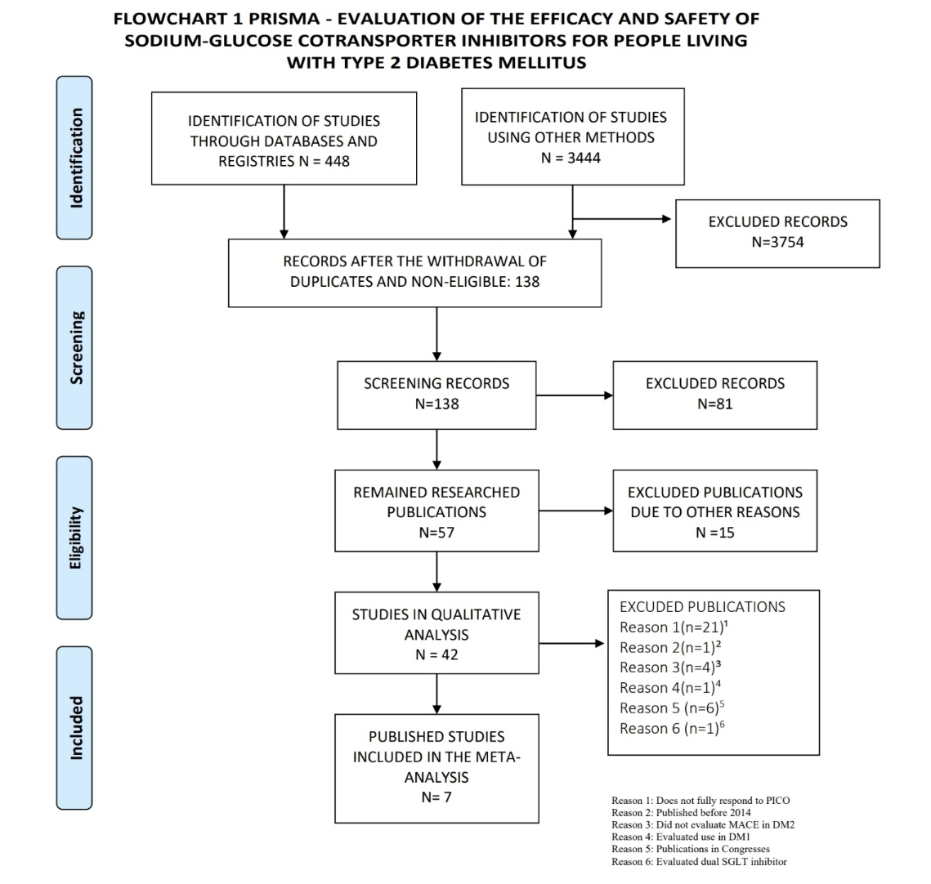
Figure 1. FLOWCHART 1 PRISMA

2.4 Data extraction
The extraction of the data was carried out by two independent reviewers and checked by a third. The extracted data were stored in a Microsoft Excel® spreadsheet, and the data were evaluated individually in non-categorical analyses.14-15
2.5 Critical appraisal and risk of bias of the included studies
The methodological quality and/or risk of bias of the included studies was assessed by two independent reviewers (H.B.F. and L.M.D.) using the ROB 2® tool for randomized clinical trials.Presentation of results and measures of treatment effect and assessment of quality of evidence. The relative risk (RR) is used to estimate the effect size of dichotomous or time-to-event variables, taking into account a 95% confidence interval. For continuous analyses, the difference between means was used. Meta-analyses were performed using Review Manager 5.3® software (RevMan 5.3). The Grading of Recommendations, Assessment, Development and Evaluation (GRADE®) system and the GRADEpro GDT® platform were used to assess the quality of evidence for outcomes included in meta-analyses [16]. Statistical heterogeneity was assessed using chi-square and I2 statistical tests. An I2 value of 0-40% is considered nonsignificant, 30-60% is considered moderate heterogeneity, 50-90% is considered substantial heterogeneity, and 75-100% is considered significant.
2.6 Ethical Considerations
No research was conducted on human subjects, and no confidential, institutional, or personal information was used. All research was based on data from studies published in electronic databases. This research project was registered in PROSPERO under the registration number CRD42022362775 on October 14, 2022. None of the authors of this meta-analysis has any conflict of interest regarding this research or has received any type of sponsorship for it.

3. RESULTS

A total of 46,969 patients were included and with a follow-up of approximately 2,49 years. 66,85% were men. The mean age of those included in the study was 64,07, and 79,8% of them were white. The average HbA1C of the patients was 8,14% and with a reduction in their levels of 0,46%, which is equivalent to a reduction of approximately 5% of the baseline HbA1C level. 66,23% of the sample had established cardiovascular disease. The average time since diabetes diagnosis was 11,48 years.
High risk of bias in the RCTs resulted in publication bias. The quality of evidence regarding the outcomes analyzed in the meta-analysis was evaluated utilizing ROB 2® and depicted in the accompanying chart (Figura 2 and 3).
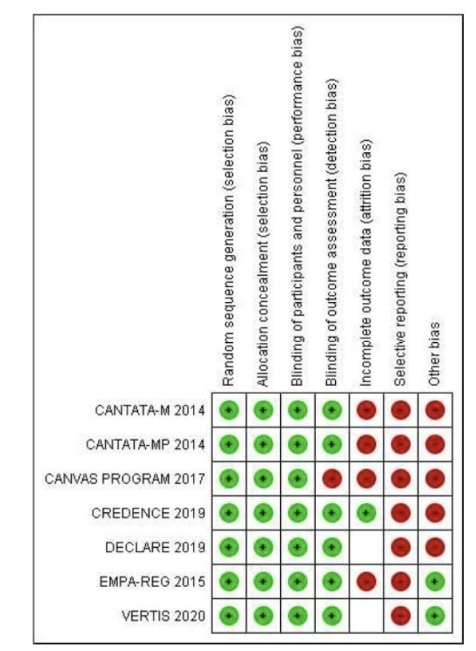
Figure 2. Graph that summarizes the risk of bias based on the authors' judgment for each item of bias risk.
Risk of bias chart 1: The authors' evaluations of each potential source of bias in all
included studies are summarized.

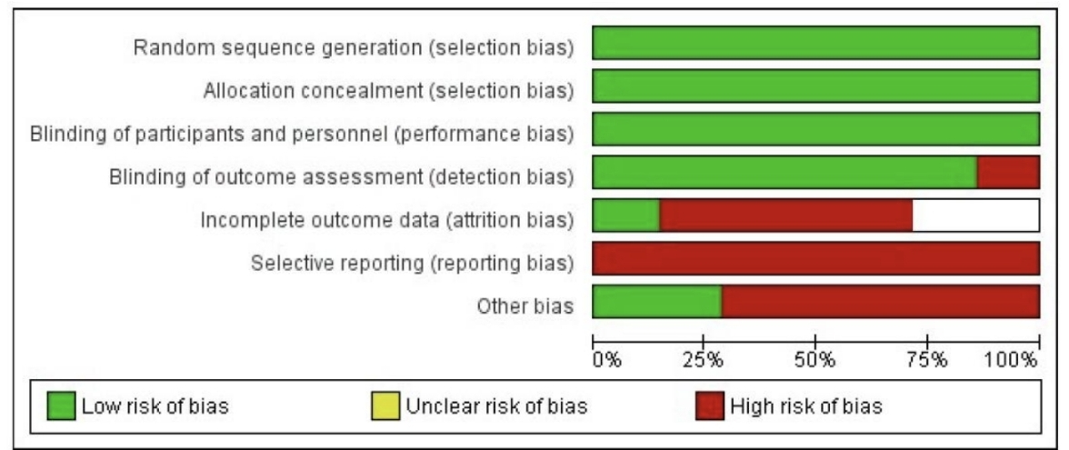
Figure 3. Bias Risk Graph: authors' judgments on each bias risk item presented as
percentages across all included studies, developed with the Software Review Manager 5.4, Belo Horizonte
Risk of bias chart 2: The authors' evaluations of each risk of bias item displayed as a percentage across all studies included.
3.1 Efficacy Results
The meta-analysis evaluated the effectiveness of the ISGLT2 drug class in treating patients with type 2 diabetes mellitus (DM2). Seven clinical trials were included in the analysis. The results showed a significant 38% reduction in the risk of cardiovascular death and hospitalization for heart failure in patients treated with ISGLT2 compared to patients treated with optimized conventional diabetes therapy (p = 0,0005; I² = 92%). There was a slight reduction in the relative risk of MACE between the two groups, but it did not reach statistical significance (RR 0,95; CI 0,86-1,16; p=0,09; I² 49%). However, CKD was associated with a statistically significant risk reduction: The RR of ISGLT2 decreased by 32% in the control group (RR 0,68; 95% CI 0,57-0,82; p<0,0001; I² 59%). The reduction in hospital admissions for heart failure was statistically significant when comparing the two groups, with a RR reduction of 0,70 (RR 0,70; 0,62 to 0,78; 95% CI; p < 0,0001; I² 0%). For the assessment of fatal or non-fatal acute myocardial infarction, there was no reduction when comparing ISGLT2 with optimized diabetes therapy, but there was a trend leading to neutrality in the experimental group versus placebo (RR 0,95; 95% CI 0,88-1,04; p=0,27; I² 1%). The study also examined the risk associated with a decrease in cardiovascular death, revealing an insignificant reduction in all-cause mortality in the experimental group as compared to the placebo cohort (RR 0,82; 95% CI 0,73-1,05; p=0,14; I² 77%). The analysis of the reduction in fatal stroke incidents revealed no significant reduction in the ISGLT2 group with a trend towards neutrality in the experimental group versus placebo (RR 0,97; 95% CI 0,85-1,12; p=0,69; I² 34%). The experimental group exhibited a noteworthy 12% decrease in all-cause mortality, reaching the boundary of the confidence interval when compared to the placebo (RR 0,88; 95% CI 0,78-0,99; p=0,04; I² 65%).
3.2 Adverse Event Findings
The meta-analysis assessed data from seven randomized clinical trials that present homogeneous and quantitative information regarding the risk of hypoglycemia. The results suggest neutrality, with only a 1% reduction of hypoglycemia observed in the control group. There was no statistically significant increase in fractures in the ISGLT2 group after its introduction, but there was a trend towards a 22% increase in relative risk in this group (p=0,19; I² 81%) based on the risk of fractures at different sites. Regarding the risk of volume depletion with or without hypotension, there was no significant increase in this undesirable effect in the ISGLT2 group, and there was a trend towards neutrality when comparing the groups (p=0,83; I² 74%). There was no significant difference in the risk of serious urinary tract infections, except for cystitis, between the control and placebo groups. The results revealed no statistically significant increase in adverse events in the ISGLT2 group, with a trend toward neutrality in the group comparison (p=0,12; I² 38%).
Additionally, the ISGLT2 group exhibited a slight but significant trend towards reduced serious general adverse events, not including death, when compared to the placebo group. Heterogeneity was evaluated through a fixed model and found to have notable variance. The relative risk (RR) showed a 15% increase (p=0,03; I² 96%) with regards to genitourinary infections in the meta-analysis of SGLT2 usage versus placebo, showing a statistically significant 327% increase in RR. Reassessment of heterogeneity yielded a substantial outcome (p<0,00001; I² 68%). Only the CANVAS, CREDENCE, DECLARE, EMPA-REG, and VERTIS studies reported findings on unscheduled discontinuation, excluding deaths, and demonstrated no statistical significance between the control and placebo discontinuation assessments, indicating a trend towards neutrality.
4. DISCUSSION

The analysis assessed eight primary outcomes and eight adverse effects documented in the RCTs. Seven were evaluated after following the previously described steps. Some studies yielded incomplete data on primary and secondary outcomes and adverse effects. 17-18-19-20 The study's sample group consisted of 75,14% white and 63.11% male patients. Further research in diverse population profiles could address gaps in this meta-analysis. Patients with established cardiovascular disease accounted for 66,23% of the RCTs population, which may present an advantageous patient profile for therapeutic optimization leading to reduced outcomes. On average, patients' HbA1C was 8,12%, and the average duration of a diabetes diagnosis was 11,05 years. This therapeutic category resulted in a slight decrease of 0,46% in Hba1C levels and a minor decrease of 3,55 and 2,75 mmHg, respectively, in systolic and diastolic blood pressure. Consequently, the use of ISGLT2 cannot be recommended for further control of blood pressure levels.
4.1 Evaluating efficacy
All studies that examined positive outcomes presented selective outcomes, indicating a high risk of bias when using the ROB 2.0 and GRADE-PRO tools. Evidence on hospitalization for HF and reduction in the progression of chronic kidney disease was found to be of high degree. Found a significant reduction of 29% in the relative risk of combined cardiovascular deaths and heart failure, despite considerable heterogeneity (RR 0,71; 95% CI; 0,58 – 0,86; p=0,0005; I² 82%). They evaluated the effect of ISGLT2 in both diabetics and non-diabetics, leading to a 25% reduction (p<0,000001). Ahmad and colleagues discovered comparable results in their study, which incorporated Sotagliflozin, to those presented in our study, with a relative risk (RR) of 0,84, 95% confidence interval (CI) of 0,71-0,98, a P-value of 0,02, and an I² of 67%.21-22
There was a 30% decrease in CHF-related hospitalizations (RR 0,70; CI 0,62-0,78; p <0,00001; I² of 0%). One study reported a statistically significant 52% reduction in CHF rehospitalizations.22 Positive results were observed in non-diabetic patients from the RCT Empagliflozin in Heart Failure with a Preserved Ejection Fraction (EMPEROR) study.23 In vitro studies, animal models, and reviews suggest that medications within this drug class impact cardiomyocytes expressing SGLT2 receptors, potentially justifying the benefits.24-25 The exclusion of heart failure hospitalizations did not lead to a significant reduction in the risk of cardiovascular death (RR 0,87; 95% CI 0,73-1,05; p=0,14). The progression of kidney disease was reduced by 32% with statistical significance (p<0,0001) according to one real-life study [24]. Their cohort also reported a 49% reduction in the combined renal outcome (95% CI 0,35-0,67; p < 0,0001).26 It evaluated the renal outcomes of ISGLT2 and Sotagliflozin in diabetics and non-diabetics. They found a significant reduction in this outcome (RR 0,70; 95% CI 0,58-0,83], p < 0,0001; I2 = 0,00%), as well as an improvement in microalbuminuria.26 However, further research is needed for primary prevention. The Taiwanese retrospective cohort studied 53,264 patients taking ISGLT2 versus DPP4. The all-cause mortality rate in SGLT2 inhibitor and DPP4 inhibitor users was 8,67 and 12,41 per 1000 person-years, respectively. Researchers evaluated 21 randomized controlled trials in patients with and without diabetes mellitus type 2 and found a 14% decrease in all-cause mortality (95% CI, 0,81; 0,91; p <0,00001).27 The current systematic review demonstrates a statistically significant 12% reduction in this outcome (p=0,04).28
Poor glycemic control, length of time since diabetes diagnosis, and early age at diabetes diagnosis are distinct risk factors that lead to major vascular events, including fatal and non-fatal AMI and stroke. In patients with DM2, no benefits in these outcomes were observed, in accordance with one meta-analysis (RR 0,955 CI 0,799-1,135; p- 0,585).29 Similarly, Other study found no significant reduction in the risk of stroke (HR, 0,86; 95% CI, 0,65-1,08).30 A comprehensive strategy is necessary for the treatment of DM2 to reduce the risk of AMI and stroke, alongside further research studies on residual risk factors.31
One RCT did not provide the absolute numbers of these events in their databases and they were indirectly determined through other publications [19]. The analysis of the data from the CREDENCE study may have been subject to publication bias and possible data imputation due to the numbers recorded in the Clinical Trial.30,32 Further investigation is required to better understand the additional cardiovascular benefits of ISGLT2. Additionally, it is critical to evaluate the adjustments made in clinical trials and any losses caused by other deaths and/or unjustified discontinuation of follow-up. New analyses will be explored to address gaps in our publication.
4.2 Evaluation of undesirable effects and safety
ISGLT2 is considered safe based on its exceptional efficacy in treating CHF patients. Most publications have limited information about the drug's adverse effects, but the Clinical Trial's data shares crucial insights. The glycosuria side effect poses a potential risk of hypoglycemia, which is the primary hindrance in achieving optimal glycemic control. Intensive glycemic control raises the risk of severe hypoglycemia by 1,5 to 3 times. Hypoglycemia occurrence is linked to increased mortality, greater risk of dementia, cognitive dysfunction, falls (including increased fractures), cardiovascular events, and poorer quality of life.31 ISGLT2's association with other AHO (p-0,56) indicates no statistical significance or effect with respect to hypoglycemia. Researchers conducted an evaluation of more than 170,000 patients taking ISGLT2 and their hospitalizations due to hypoglycemia.31 The results showed no increase in the risk of hospitalizations.30 However, the use of ISGLT2 along with insulin demonstrated a 3,26-fold increase (OR 3,26; 95% CI 2,43-4,38). This increased risk occurred more commonly in frail elderly individuals and those on insulin therapy. Thus, further studies are required to establish the safety of this treatment despite the benefits of its efficacy. Fracture risk also remains a significant concern. Researchers conducted a COX proportional hazards analysis of ISGLT2 versus IDPP4, which revealed no significant difference between the two groups: 0,95 (95% CI, 0.79-1.13) and 0,88 (95% CI, 0,88-1,00), respectively.33-34 An additional analysis involving 137,667 individuals with DM2 and ≥65 years old without previous fractures identified a difference among new users of ISGLT2 versus IDPP4 or GLP1 analogues.35 The trend showed an increase of 1,22, but the risk did not significantly rise (p-0,19). Ruanpeng and colleagues assessed 8,286 participants diagnosed with type 2 diabetes in phase 2 and 3 randomized controlled trials. They found that the risk of fracture was 33% lower (RR 0,67; 95% CI, 0,42-1,07).36 In a second meta-analysis of 27 RCTs in type 2 diabetes, the authors found no statistically significant increase in the risk of fractures (RR 1,02 95% CI 0,81-1,28).25 Our findings differ from the aforementioned studies and may be due to the exclusion of phase 2 clinical trials and non-"double-blind" studies.37
The CANVAS-PROGRAM study revealed a notable rise in fractures, primarily in the limbs, which do not classify as fragility fractures. This upswing in fractures can be attributed to the fact that the participants chosen for the study had advanced kidney disease and some level of peripheral arterial disease. Publishing the results in "person-years" may indicate a publication bias.30,32 There was no significant distinction between the groups (p-0,83), and the risk of hypotension did not increase. Rong and colleagues found no statistically significant increase in the aforementioned risk (RR 1,17; 95% CI: 0,65-2,09). However, there was a higher incidence of hypotension in patients who were under the age of 60 and/or those whose mean blood pressure was ≤130x90 mmHg prior to initiating treatment. In Other subsequent study in 2022, it was reported that there is an increased risk of hypovolemia (RR 1,12 95% CI: 1,02-1,22) in patients with an estimated glomerular filtration rate (GFR) <60 mL/min/1.73 m².35 Most studies excluded patients with a GFR <20 mL/min/1.73m² or systolic blood pressure (SBP) <100. The potential for orthostatic hypotension should be considered in patients who are elderly, have long-standing diabetes, and have certain blood pressure levels at baseline, as well as in patients with comorbidities.38 The potential for orthostatic hypotension should be considered in patients who are elderly, have long-standing diabetes, and have certain blood pressure levels at baseline, as well as in patients with comorbidities. A substantial rise of 327% (p-<0,00001) in genitourinary mycotic infections was observed. It is suggested that patients at higher risk for mycotic infections be categorized, though there is a shortage of analyses that assess this side effect.
There was a slight trend towards an increased risk of severe urinary infections, which lacked statistical significance (p=0,12). An observational study, conducted between 2019 and 2021, on 853 UTI patients admitted to the hospital, showed that the risk of UTI was higher by 3,70 times in ISGLT2 users compared to those under conventional therapy, with a p-value less than 0,001. Additionally, the risk was higher in women (OR 1,75; p=0,031). However, the findings contradict this study, which included over 700,000 patients and found no significant increase in outpatient UTI risk (OR 0,98; 95% CI, 0,68-1,41). Therefore, for patients with low UTI risk, ISGLT2 appears to be a safe option.40 Nevertheless, the lack of clear explanation for discontinuation remains a critical limitation in this systematic review.
Our study's primary limitations included variations in the eligibility of selected DM2 patients, discrepancies in the duration of RCTs, and inadequate specification regarding the degree and timing of established cardiovascular disease in most patients. As a result, further research is required to clarify the impact of this category of drugs on primary prevention. The considerable amount of inaccessible or incomplete primary data may prevent a fully accurate analysis, which could be rectified if the authors were able to retrieve all the data. Our systematic review did not encompass real-life studies. As real-life studies and clinical trials in specific subpopulations are published, our assumed gaps may be filled over time.

5. CONSIDERAÇÕES FINAIS

Treatment with ISGLT2 in patients with type 2 diabetes mellitus reduced the rate of hospitalization for heart failure and slowed the progression of kidney disease or combined renal outcomes. However, these drugs did not significantly affect the major combined endpoint. The reduction in mean glycated hemoglobin levels was minor or insignificant, and glycemic control was inadequate to meet recommended targets. Risk-based prescribing criteria need to be developed for female patients, patients with long-standing diabetes, patients who are at risk of urinary tract infections, frail patients, and those at risk of fractures. Additionally, there is a need to gain better insight into the effects of this drug class on primary prevention.

REFERÊNCIAS
1. Fang M, Wang D, Coresh J, Selvin E. Trends in diabetes treatment and control in US adults, 1999–2018. N Engl J Med. 2021 Jun 10;384(23):2219-28. Disponível em: http://dx.doi.org/10.1056/nejmsa2032271
2. Braunwald E. Gliflozins in the management of cardiovascular disease. N Engl J Med. 2022 May 26;386(21):2024-34. Disponível em: http://dx.doi.org/10.1056/nejmra2115011
3. Bikbov B, Purcell CA, Levey AS, Smith M, Abdoli A, Abebe M, et al. Global, regional, and national burden of chronic kidney disease, 1990–2017: a systematic analysis for the Global Burden of Disease Study 2017. Lancet. 2020 Feb;395(10225):709-33. Disponível em: http://dx.doi.org/10.1016/s0140-6736(20)30045-3
4. Borges FA, Silva CA, Crajoinas RO, Castelo-Branco RC, Luchi WM, Girardi AC. Empagliflozin inhibits NHE3 activity in the proximal tubule of normotensive and hypertensive rats. FASEB J. 2018 Apr;32(1):1513-26. Disponível em: http://dx.doi.org/10.1096/fasebj.2018.32.1_supplement.lb355
5. The EMPA-KIDNEY Collaborative Group. Empagliflozin in patients with chronic kidney disease. N Engl J Med. 2023 Jan 12;388(2):117-27. Disponível em: http://dx.doi.org/10.1056/nejmoa2204233
6. International Diabetes Federation. IDF Diabetes Atlas. Brussels: International Diabetes Federation; 2015.
7. Triozzi JL, Gregg LP, Virani SS, Navaneethan SD. Management of type 2 diabetes in chronic kidney disease. BMJ Open Diabetes Res Care. 2021 Jul;9(1):e002300. Disponível em: http://dx.doi.org/10.1136/bmjdrc-2021-002300
8. Salehidoost R, Mansouri A, Amini M, Aminorroaya SA, Aminorroaya A. Diabetes and all-cause mortality: an 18-year follow-up study. Sci Rep. 2020 Feb 21;10(1):2890. Disponível em: http://dx.doi.org/10.1038/s41598-020-60142-y
9. Higgins JPT, Savovic J, Page MJ, Elbers RG, Sterne JAC. Assessing risk of bias in a randomized trial. In: Higgins JPT, Thomas J, Chandler J, Cumpston M, Li T, Page MJ, Welch VA, editors. Cochrane Handbook for Systematic Reviews of Interventions. 2nd ed. Chichester (UK): John Wiley & Sons; 2019. p. 205-28. Disponível em: http://dx.doi.org/10.1002/9781119536604.ch8
10. Shea BJ, Reeves BC, Wells G, Thuku M, Hamel C, Moran J, et al. AMSTAR 2: a critical appraisal tool for systematic reviews that include randomised or non-randomised studies of healthcare interventions, or both. BMJ. 2017 Sep 21;358:j4008. Disponível em: http://dx.doi.org/10.1136/bmj.j4008
11. Moher D, Liberati A, Tetzlaff J, Altman DG. Preferred reporting items for systematic reviews and meta-analyses: the PRISMA statement. PLoS Med. 2009 Jul 21;6(7):e1000097. Disponível em: http://dx.doi.org/10.1371/journal.pmed.1000097
12. Santos CMC, Pimenta CA, Nobre MRC. The PICO strategy for the research question construction and evidence search. Rev Latino-Am Enfermagem. 2007 Jun;15(3):508-11. Disponível em: http://dx.doi.org/10.1590/s0104-11692007000300023
13. Aromataris E, Pearson A. The systematic review. Am J Nurs. 2014 Mar;114(3):53-8. Disponível em: http://dx.doi.org/10.1097/01.naj.0000444496.24228.2c
14. Ouzzani M, Hammady H, Fedorowicz Z, Elmagarmid A. Rayyan: a web and mobile app for systematic reviews. Syst Rev. 2016 Dec;5(1):210. Disponível em: http://dx.doi.org/10.1186/s13643-016-0384-4
15. McGuinness LA, Higgins JPT. Risk-of-bias VISualization (robvis): an R package and shiny web app for visualizing risk-of-bias assessments. Res Synth Methods. 2021 Jan;12(1):55-61. Disponível em: http://dx.doi.org/10.1002/jrsm.1411
16. Brasil. Ministério da Saúde. Secretaria de Ciência, Tecnologia e Insumos Estratégicos. Departamento de Ciência e Tecnologia. Diretrizes metodológicas: Sistema GRADE – Manual de graduação da qualidade da evidência e força de recomendação para tomada de decisão em saúde. Brasília: Ministério da Saúde; 2014.
17. Bhatia J, Gamad N, Bharti S, Arya DS. Canagliflozin: current status in the treatment of type 2 diabetes mellitus with focus on clinical trial data. World J Diabetes. 2014 Jun 15;5(3):399-406. Disponível em: http://dx.doi.org/10.4239/wjd.v5.i3.399
18. Stenlöf K, Cefalú WT, Kim KA, et al. Eficácia e segurança a longo prazo da monoterapia com canagliflozina em doentes com diabetes tipo 2 inadequadamente controlados com dieta e exercício: resultados do estudo CANTATA-M de 52 semanas. Curr Med Res Opin. 2014 Feb;30(2):163-75. Disponível em: http://dx.doi.org/10.1185/03007995.2013.850066
19. Zinman B, Wanner C, Lachin JM, Fitchett D, Bluhmki E, Hantel S, et al. Empagliflozin, cardiovascular outcomes, and mortality in type 2 diabetes. N Engl J Med. 2015 Nov 26;373(22):2117-28. Disponível em: http://dx.doi.org/10.1056/nejmoa1504720
20. Neal B, Perkovic V, Mahaffey KW, de Zeeuw D, Fulcher G, Erondu N, et al. Canagliflozin and cardiovascular and renal events in type 2 diabetes. N Engl J Med. 2017 Aug 17;377(7):644-57. Disponível em: http://dx.doi.org/10.1056/nejmoa16119252 Santos RNM, Kobashi NY. Bibliometria, cientometria, infometria: conceitos e aplicações. Pesq bras Ci Inf. 2009;2(1):155-172.
21. Zaccardi F, Webb DR, Htike ZZ, Youssef D, Khunti K, Davies MJ. Efficacy and safety of sodium-glucose co-transporter-2 inhibitors in type 2 diabetes mellitus: systematic review and network meta-analysis. Diabetes Obes Metab. 2016 Aug;18(8):783-94. Disponível em: http://dx.doi.org/10.1111/dom.12670
22. Ahmad E, Lim S, Lamptey R, Webb DR, Davies MJ. Type 2 diabetes. Lancet. 2022 Nov;400(10365):1803-20. Disponível em: http://dx.doi.org/10.1016/s0140-6736(22)01655-5.
23. Salah HM, Al'Aref SJ, Khan MS, Al-Hawwas M, Vallurupalli S, Mehta JL, et al. Efficacy and safety of sodium-glucose cotransporter 2 inhibitors initiation in patients with acute heart failure, with and without type 2 diabetes: a systematic review and meta-analysis. Cardiovasc Diabetol. 2022 Feb 5;21(1):48. Disponível em: http://dx.doi.org/10.1186/s12933-022-01455-2
24. Anker SD, Butler J, Filippatos G, Ferreira JP, Bocchi E, Böhm M, et al. Empagliflozin in heart failure with a preserved ejection fraction. N Engl J Med. 2021 Oct 14;385(16):1451-61. Disponível em: http://dx.doi.org/10.1056/nejmoa2107038
25. Pabel S, Hamdani N, Luedde M, Sossalla S. SGLT2 inhibitors and their mode of action in heart failure—has the mystery been unraveled? Curr Heart Fail Rep. 2021 Sep;18(5):315-28. Disponível em: http://dx.doi.org/10.1007/s11897-021-00529-8
26. Heerspink HJL, Karasik A, Thuresson M, Melzer-Cohen C, Chodick G, Khunti K, et al. Kidney outcomes associated with use of SGLT2 inhibitors in real-world clinical practice (CVD-REAL 3): a multinational observational cohort study. Lancet Diabetes Endocrinol. 2020 Jan;8(1):27-35. Disponível em: http://dx.doi.org/10.1016/s2213-8587(19)30384-5
27. Chung MC, Hung PH, Hsiao PJ, Wu LY, Chang CH, Wu MJ, et al. Association of sodium-glucose transport protein 2 inhibitor use for type 2 diabetes and incidence of gout in Taiwan. JAMA Netw Open. 2021 Nov 19;4(11):e2135353. Disponível em: http://dx.doi.org/10.1001/jamanetworkopen.2021.35353
28. Silverii GA, Monami M, Mannucci E. Sodium-glucose co-transporter-2 inhibitors and all-cause mortality: a meta-analysis of randomized controlled trials. Diabetes Obes Metab. 2020 Dec;23(4):1052-6. Disponível em: http://dx.doi.org/10.1111/dom.14286
29. D’Andrea E, Wexler DJ, Kim SC, Paik JM, Alt E, Paterno E. Comparing effectiveness and safety of SGLT2 inhibitors vs DPP-4 inhibitors in patients with type 2 diabetes and varying baseline HbA1c levels. JAMA Intern Med. 2023 Mar 1;183(3):242-50. Disponível em: http://dx.doi.org/10.1001/jamainternmed.2022.6664
30. Perkovic V, Jardine MJ, Neal B, Bompoint S, Heerspink HJL, Charytan DM, et al. Canagliflozin and renal outcomes in type 2 diabetes and nephropathy. N Engl J Med. 2019 Jun 13;380(24):2295-306. Disponível em: http://dx.doi.org/10.1056/nejmoa1811744
31. Lipska KJ, Warton EM, Huang ES, Moffet HH, Inzucchi SE, Krumholz HM, et al. HbA1c and risk of severe hypoglycemia in type 2 diabetes. Diabetes Care. 2013 Oct 15;36(11):3535-42. Disponível em: http://dx.doi.org/10.2337/dc13-0610
32. Neal B, Perkovic V, Mahaffey KW, de Zeeuw D, Fulcher G, Erondu N, et al. Canagliflozin and cardiovascular and renal events in type 2 diabetes. N Engl J Med. 2017 Aug 17;377(7):644-57. Disponível em: http://dx.doi.org/10.1056/nejmoa1611925
33. Horii T, et al. Real-world risk of hypoglycemia-related hospitalization in Japanese patients with type 2 diabetes using SGLT2 inhibitors: a nationwide cohort study. BMJ Open Diabetes Res Care. 2020;8(2):e001856.
34. Cowan A, Jeyakumar N, Kang Y, Dixon SN, Garg AX, Naylor K, et al. Fracture risk of sodium-glucose cotransporter-2 inhibitors in chronic kidney disease. Clin J Am Soc Nephrol. 2022 Jun;17(6):835-42. Disponível em: http://dx.doi.org/10.2215/cjn.16171221
35. Zhuo M, Hawley CE, Paik JM, Bessette LG, Wexler DJ, Kim DH, et al. Association of sodium-glucose cotransporter-2 inhibitors with fracture risk in older adults with type 2 diabetes. JAMA Netw Open. 2021 Oct 27;4(10):e2130762. Disponível em: http://dx.doi.org/10.1001/jamanetworkopen.2021.30762
36. Ruanpeng D, Ungprasert P, Sangtian J, Harindhanavudhi T. Sodium-glucose cotransporter 2 (SGLT2) inhibitors and fracture risk in patients with type 2 diabetes mellitus: a meta-analysis. Diabetes Metab Res Rev. 2017 Jun;33(6):e2903. Disponível em: http://dx.doi.org/10.1002/dmrr.2903
37. Li N, et al. Effects of SGLT2 inhibitors on renal outcomes in patients with chronic kidney disease: a meta-analysis. Front Med. 2021;8:728089. Disponível em: http://dx.doi.org/10.3389/fmed.2021.728089
38. Rong X, Li X, Gou Q, Liu K, Chen X. Risk of orthostatic hypotension associated with sodium-glucose cotransporter-2 inhibitor treatment: a meta-analysis of randomized controlled trials. Diabetes Vasc Dis Res. 2020 Sep;17(5):147916412095362. Disponível em: http://dx.doi.org/10.1177/1479164120953625
39. Böhm M, Anker SD, Butler J, Filippatos G, Ferreira JP, Pocock SJ, et al. Empagliflozin improves cardiovascular and renal outcomes in heart failure irrespective of systolic blood pressure. J Am Coll Cardiol. 2021 Sep 28;78(13):1337-48. Disponível em: http://dx.doi.org/10.1016/j.jacc.2021.07.049
40. Dave CV, Schneeweiss S, Kim D, Fralick M, Paterno E. Sodium-glucose cotransporter-2 inhibitors and urinary tract infections. Ann Intern Med. 2019 Dec 17;171(12):944-51. Disponível em: http://dx.doi.org/10.7326/l19-06714 Ministério da Saúde (Brasil). Portaria n. 930, de 27 de agosto de 1992. Expede normas pra o controle das infecções hospitalares. Brasília: Diário Oficial da União; 4 set 1992, Seção 1.

